Access to Clean Water in Rural African Communities

Introduction
Access to clean and safe water is one of the most critical challenges facing rural communities across Africa. Water is essential not only for drinking, but also for sanitation, hygiene, food production, and overall human dignity. Despite its importance, millions of people living in rural African regions still rely on unsafe and unreliable water sources such as rivers, shallow wells, and seasonal streams. These sources are often contaminated and vulnerable to drought, placing communities at constant risk of water-borne diseases. The lack of adequate water infrastructure highlights deep inequalities between rural and urban areas, where piped water systems are more common and reliable.
The struggle for clean water in rural Africa is more than a physical hardship; it is a social and developmental issue that affects every aspect of daily life. Long distances to water sources consume valuable time, particularly for women and children, limiting opportunities for education, economic participation, and social advancement. Poor water access also weakens health systems and reinforces cycles of poverty and vulnerability. Through photographs and visual storytelling, this essay explores the realities of water scarcity, the health and social consequences of unsafe water, and the resilience of rural communities striving to secure sustainable solutions for clean water access.

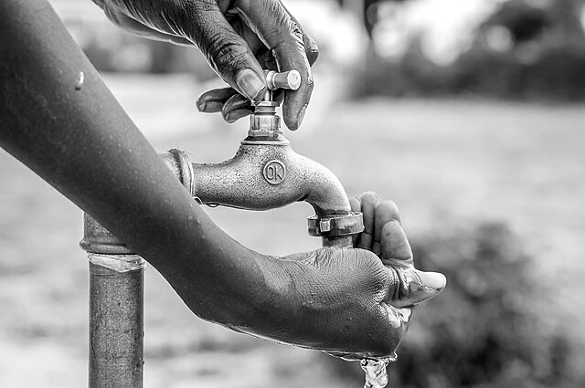

1. The Daily Burden of Water Collection
In countless rural communities across Africa, clean and safe water remains a distant dream. Rural residents often walk long distances, sometimes more than thirty minutes each way, to reach a water point that may only offer unsafe water from unprotected wells, rivers, or seasonal streams. This daily burden overwhelmingly falls on women and girls, who shoulder heavy jerry cans on foot or by wheelbarrow, sacrificing hours that could otherwise be spent in school, work, or rest. In sub-Saharan Africa the divide between rural and urban access is stark: while many urban households have piped water, less than one in five rural dwellers enjoys this basic service.
The physical hardship is also a barrier to broader development. Long journeys for water mean that rural families begin and end their days tethered to distant and often unreliable water sources. Beyond the time cost, there is a health risk: unprotected sources are prone to contamination from bacteria, parasites, and environmental pollution, contributing to diarrhoeal diseases and other serious illnesses. Public health institutions report that lack of safe water and sanitation remains a leading cause of disease in the African region, affecting both children’s health and community livelihoods.
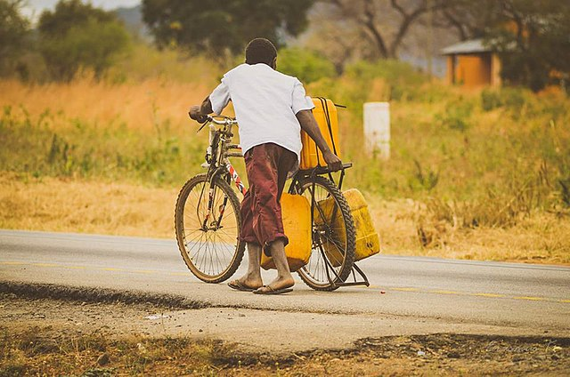

2. Unsafe Sources and Water Scarcity
Water scarcity and contamination are interlinked challenges in rural Africa. In many regions, infrastructure is sparse or nonexistent, leaving families to rely on shallow wells, untreated surface water, and rainwater catchments that do not meet safety standards. Rural access figures illustrate this disparity: in countries such as Tanzania or Nigeria, rural regions lag far behind urban centers, with far lower proportions of households having access to basic drinking water services.
These inadequate water sources contribute directly to illness and environmental hardship. Communities dependent on rivers or open ponds must contend with water that may carry pathogens, chemical pollutants, or waste runoff from nearby fields. When rainfall is erratic — a situation that is worsening in many parts of Africa due to climate change — sources shrink or disappear entirely, leaving people to compete for ever scarcer supplies. The result is a cycle of scarcity and disease that hinders economic development and undermines community resilience.

Women fetching polluted water;
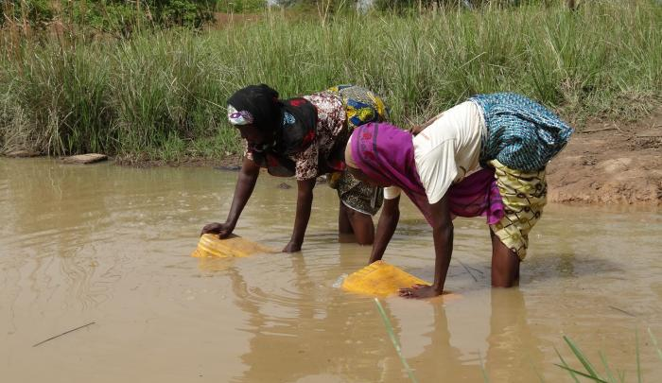

3. Health Impacts and Social Consequences
Contaminated water and lack of sanitation exact a heavy toll on public health. Without reliable access to clean water, communities are far more likely to experience outbreaks of water-borne diseases such as cholera, dysentery, typhoid, and parasitic infections. Health organizations report that water scarcity affects a significant portion of the population in Africa and is linked to preventable illnesses and deaths, especially among children.
The social impacts are equally profound. Time spent fetching water keeps children, particularly girls, out of school and reduces opportunities for adult participation in income-earning activities. The burden of unsafe water contributes to a cycle of poverty, reducing productivity and reinforcing inequalities. In school settings, lack of clean water limits hygiene practices like handwashing, making it harder to prevent disease spread and diminish educational outcomes over time.
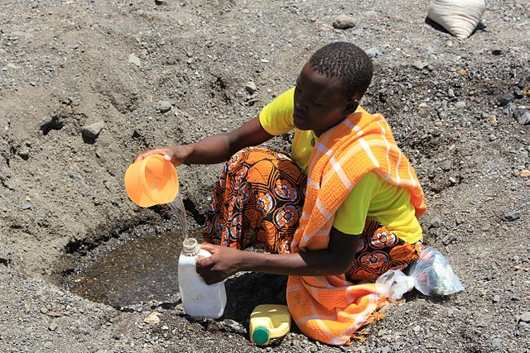

4. Community Solutions and Resilience
Despite these challenges, many rural African communities are demonstrating resilience through locally driven water solutions. Community wells, solar-powered boreholes, hand pumps, rainwater harvesting systems, and sand dams (especially in arid regions) are helping to capture and store water more effectively. In parts of Kenya, for example, sand dams built on seasonal rivers are now providing reliable water throughout the year and have reduced the distances women and children must walk.
These innovations not only improve access to clean water but also foster community engagement and sustainability. Local water committees manage maintenance and repairs, and partnerships with NGOs and governments provide technical support and funding. Such solutions empower villages, increase agricultural productivity, and improve overall health outcomes by ensuring that water is available, safe, and closer to home.
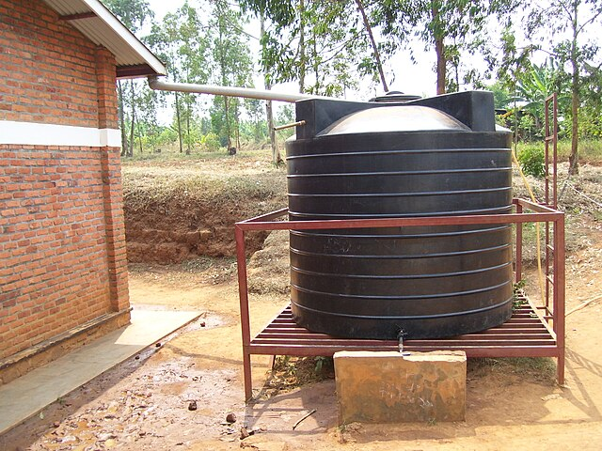

Conclusion
Access to clean water remains one of the most pressing challenges facing rural communities across Africa, with far-reaching consequences for health, education, and economic development. The photographic narratives presented in this essay reveal the daily realities of water scarcity — from long, exhausting journeys to unsafe water sources to the persistent threat of water-borne diseases. These images highlight how inadequate water access reinforces poverty and social inequality, particularly affecting women and children who bear the greatest responsibility for water collection. Without reliable clean water, efforts toward sustainable development, improved health outcomes, and educational advancement remain severely constrained.
However, the visual stories also point to hope and resilience within these communities. Community-led water projects, improved infrastructure, and partnerships with governments and humanitarian organizations demonstrate that sustainable solutions are achievable. When clean water sources such as boreholes, protected wells, and rainwater harvesting systems are introduced, they transform daily life by improving health, saving time, and restoring dignity. Addressing rural water access is not merely a humanitarian obligation but a foundation for long-term social and economic progress. Ensuring clean water for rural African communities is essential for building healthier, more resilient societies and securing a sustainable future for generations to come.

